# Assignment -4

|  |  |
| --- | --- |
| Assignment Date | 31 October 2022 |
| Student Name | KANNAN T |
| Team ID | PNT2022TMID50617 |
| Project Name | Project-Smart Farmer-IoT Enabled Smart  Farming Application |
| Maximum Marks | 2 Marks |

***Question-1:***

# Write code and connections in wokwi for ultrasonic. Whenever distance is less than 100 cms send “alert” to ibm cloud and display in device recent events.

***Solution:***

#define ECHO_PIN 2

#define TRIG_PIN 3

#define organisation = “a09qmv” #define deviceType **=** “device1”

#define deviceId =”1234”

#define authMethod =”use-token-auth” #define authToken =”12345678”

void setup() { Serial.begin(9600); pinMode(TRIG_PIN, OUTPUT); pinMode(ECHO_PIN, INPUT);

}

float readDistanceCM() { digitalWrite(TRIG_PIN, LOW); delayMicroseconds(2); digitalWrite(TRIG_PIN, HIGH); delayMicroseconds(10); digitalWrite(TRIG_PIN, LOW);

int duration = pulseIn(ECHO_PIN, HIGH); return duration * 0.034 / 2;

}

void loop() {

float distance = readDistanceCM();

if(distance <= 100)

{

Serial.println("person detected ");

}

else{

Serial.print("Measured distance: "); Serial.println(readDistanceCM());

}

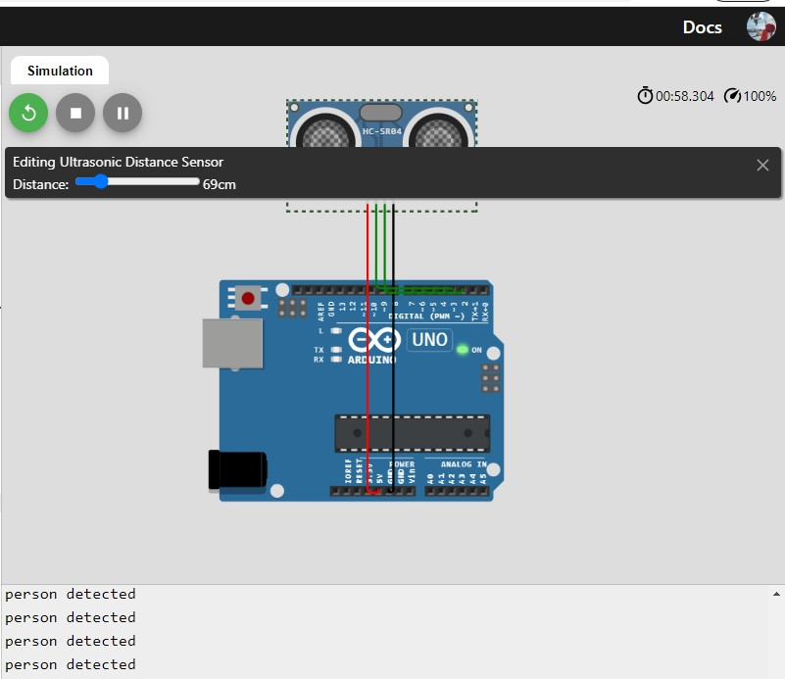delay(1000); }

# Wokwi Link



|  |
| --- |
| ***IBM Cloud***  Device Recent Events |
|  |

